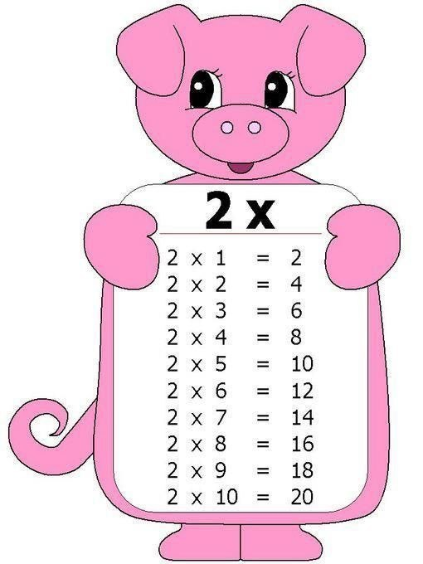

2x2=4
2x3=6
2x4=8
2x5=10
2x6=12
2x7=14
2x8=16
2x9=18

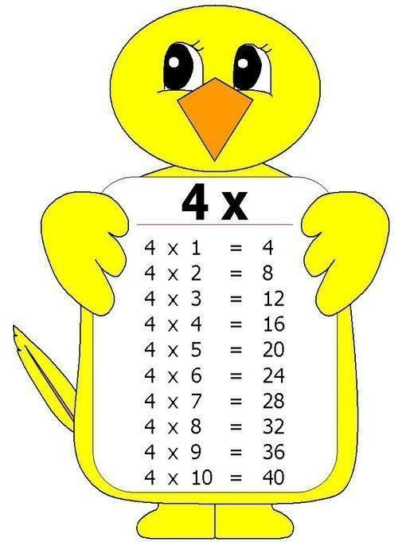

4x2=8
4x3=12
4x4=16
4x5=20
4x6=24
4x7=28
4x8=32
4x9=36

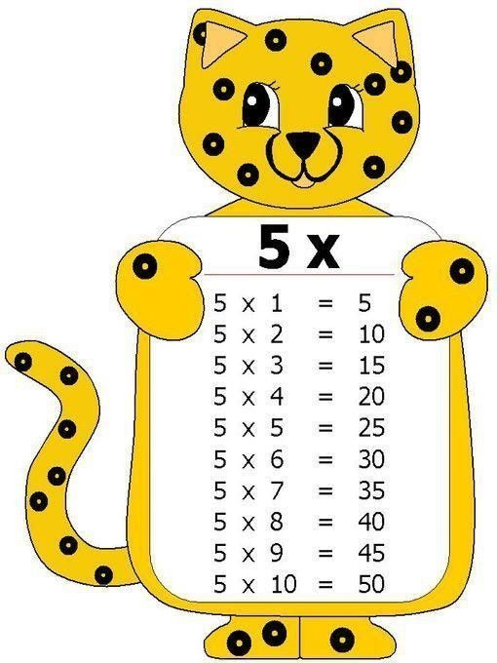

5x2=10
5x3=15
5x4=20
5x5=25
5x6=30
5x7=35
5x8=40
5x9=45

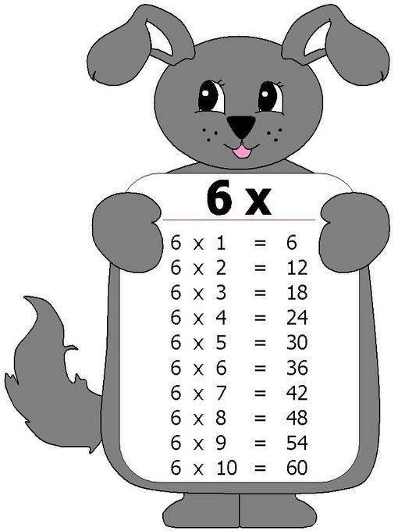

6x2=12
6x3=18
6x4=24
6x5=30
6x6=36
6x7=42
6x8=48
6x9=54

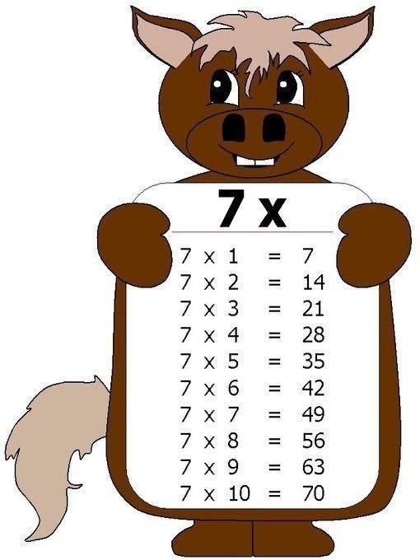

7x2=14
7x3=21
7x4=28
7x5=35
7x6=42
7x7=49
7x8=56
7x9=63

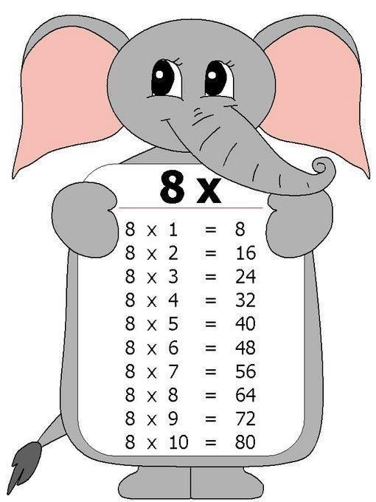

8x2=16
8x3=248x4=32
8x5=40
8x6=48
8x7=56
8x8=64
8x9=72

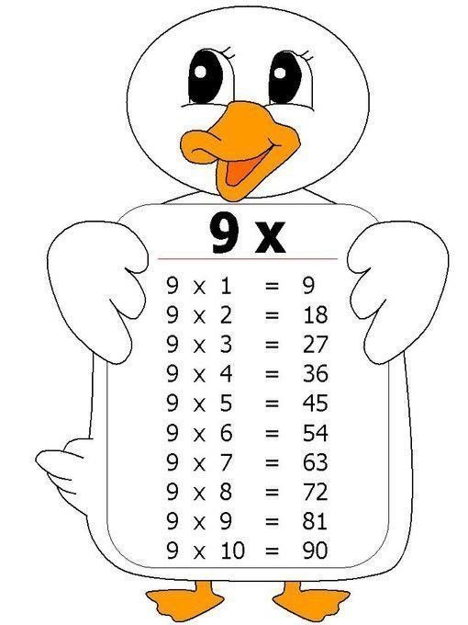

9x2=18
9x3=27
9x4=36
9x5=45
9x6=54
9x7=63
9x8=72
9x9=81

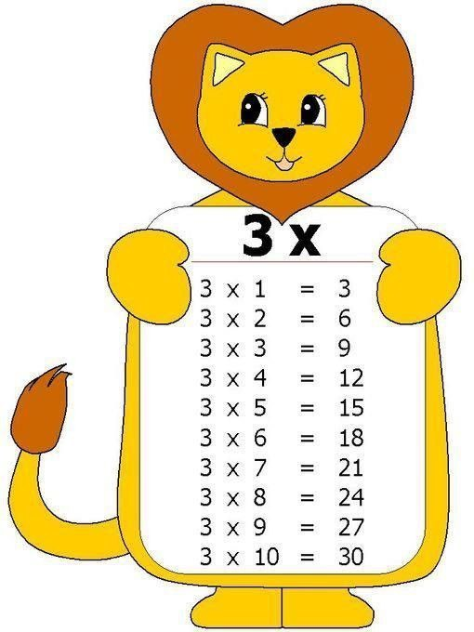

3x2=6
3x3=9
3x4=12
3x5=15
3x6=18
3x7=21
3x8=24
3x9=27

